
Great Northern Packaging
3465 Moser St., Oshkosh, WI
Production Benefit Summary



Lauren Basler
Human Resources Manager
(920)651-1807
lbasler@greatnortherncorp.com

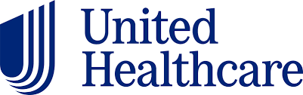
Health Insurance
 | Low Deductible HSA | High Deductible HSA | Option C
Deductible | $1700 Indivdual | $3000 Individual | No Coverage $1200 annually paid to employee
Deductible | $3400 Family | $6000 Family | No Coverage $1200 annually paid to employee
Out of Pocket Max | $3400 Individual | $4000 Individual | No Coverage $1200 annually paid to employee
Out of Pocket Max | $6800 Family | $7350 Family | No Coverage $1200 annually paid to employee
Monthly Employee Cost | Family - $586.81 | Family - $333.03 | No Coverage $1200 annually paid to employee
Monthly Employee Cost | EE+Spouse - $409.32 | EE+Spouse - $231.56 | No Coverage $1200 annually paid to employee
Monthly Employee Cost | EE+Children - $338.32 | EE+Children - $190.43 | No Coverage $1200 annually paid to employee
Monthly Employee Cost | Single - $169.16 | Single - $95.21 | No Coverage $1200 annually paid to employee

New team members will become eligible for insurance on the 1st of the month following 30 calendar days of employment. The pricing seen above is per month.

Health Savings Account (HSA)
Great Northern offers an HSA Account through Optum Bank. You can take advantage of this tax-free health savings account beginning the 1st of the month following 30 days of employment. In addition to Employee Contributions, there is also an Employer contribution each pay period, which is determined by the plan that you take and your annual Health Risk Assessment Score along with Health Coaching, if necessary, based on your Health Risk Assessment (HRA) score. The maximum annual company contribution to your HSA is $500 for a single plan and $1000 for any other than a single plan.
Flexible Spending Account (FSA)
Flexible Spending accounts for both medical reimbursement and dependent care are also available. FSA’s provide an opportunity to pay for medical and child care expenses with pretax dollars. There is no company contribution. The plan is administered by Employee Benefit Corporation. You become eligible for the FSA the 1st of the month after 30 days of employment. HSA participants are restricted to a "limited" Health Care Reimbursement Flexible Spending Plan for dental and vision only.

Advocate4Me
Advocate4Me is a free service of our healthcare plans that you can use to help answer questions that you have, to help better understand your benefits, and help find a quality provider. They are available Monday-Friday during regular business hours. You can utilize this by logging on to www.myuhc.com or on the UnitedHealthcare app and clicking on Call or Chat, or calling the number on the back of your Medical ID card.
Virtual Visits
United Healthcare provides 24/7 care through Virtual Visits if you are enrolled in Great Northern’s Medical Plan. You can access virtual visits through myuhc.com, the United Healthcare app or calling (855)615-8335. Virtual Visits cost $50 or less, and can address common issues like allergies, bronchitis, eye infections, headaches/migraines, sore throats, stomachache, rashes, and more issues affecting you and your dependents.

Dental Plans
Effective the 1st of the month following 30 days of employment.
Humana 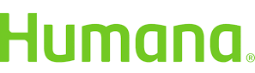
$50 Deductible, Covers Cleaning and Examinations at 100%, Annual Maximum benefit is $1500 per individual.
Pricing (Per Month):
Family: $29.46 EE+Spouse: $16.19 EE+Children: $19.91 Single: $8.09


Care Plus – Dental HMO through Dental Associates
No Deductible. Covers Cleanings and Examinations at 100%. Annual Maximum benefit is $1750 per individual.
Pricing (Per Month):
Family: $23.15 EE+Spouse: $14.34 EE+Children: $18.52 Single: $6.61

Voluntary Vision Plans
Effective the 1st of the month following 30 days of employment.
Vision care is provided for eligible Great Northern Corporation team members and their beneficiaries through Humana. It provides coverage for routine eye exams and pays all or a portion of the cost of glasses or contact lenses if you need them.
Pricing (Per Month):
Family: $17.99 EE+Spouse: $12.36 EE+Children: $11.32 Single: $6.18
Retirement Plan
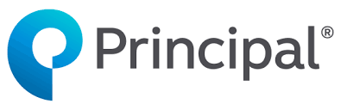
401k with Company Match
Great Northern Corporation will match 100% of the team member’s first 3% of contribution and 50% of the team member’s next 2% of contribution that is deferred to their company Retirement Plan. The employer match is always 100% vested.
New team members are eligible the first of the month following 3 months of employment.
Profit Sharing
In addition to the employer match, Great Northern provides an annual discretionary profit-sharing contribution based on the company’s performance. The maximum company contribution to retirement savings, including both 401(k) match and profit sharing is 15% of total annual eligible wage base. Great Northern has a long history of generous contributions to profit sharing.
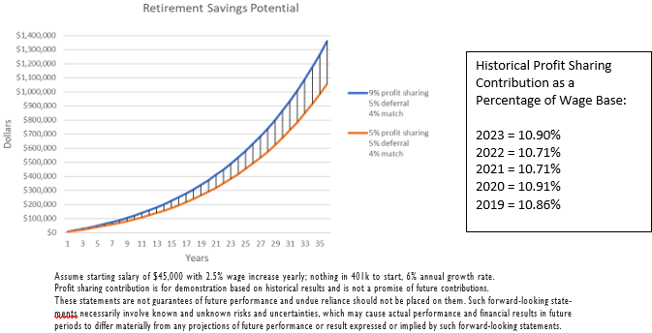
Participation starts after one full year of emloyment and working 1000 hours in the first 12 months. The effective date of participation is retroactive to the first day of the calendar year preceeding eligibility. Participants need to work at least 1000 hours and be employed at year end to receive the annual contribution which is made in March of the following year. Profit Sharing balances vest at 20% per year; 100% vested after five years service.
Vacation/Holidays
Vacation
Vacation benefits will become effective for eligible team members following 30 calendar days of employment. Vacation the first year will be prorated as such:
After the first year, the vacation schedule is as follows:
Holidays
Great Northern offers 11 paid holidays to all their team members. 2025 Holidays are as follows:
Holiday | 12's | 8's and 10's
New Years Day | Thursday, January 1 | Thursday, January 1
Easter | Saturday, April 4 | Friday, April 3
Memorial Day | Monday, May 25 | Monday, May 25
Independence Day Holiday | Friday, July 3 | Thursday, July 2
Independence Day Holiday | Saturday, July 4 | Friday, July 3
Labor Day | Monday, September 7 | Monday, September 7
Thanksgiving Day | Thursday, November 26 | Thursday, November 26
Thanksgiving Holiday | Friday, November 27 | Friday, November 27
Christmas Holiday | Thursday, December 24 | Thursday, December 24
Christmas | Friday, December 25 | Friday, December 25
New Year's Holiday | Thursday, December 31 | Thursday, December 31

On Site Nursing and Near Site Clinic
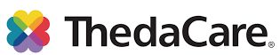
Great Northern Corporation has an on-site nurse at our Oshkosh location, and a near-site clinic at our Appleton location through ThedaCare. You can see the Nurses for a variety of minor issues. The benefit of this is that it is convenient and free to use for team members and their dependents. The following is just a few ways that you can use the Nurses:
- Acute Care Services (Cold, Flu, sore throat, cough, sinus concerns)
- Minor Injuries (strains, sprains, bruises, scrapes, athletic injuries)
- Lifestyle Medicine Visits (High Blood Pressure, Cholesterol, Depression/Anxiety)
- Sports/Camp Physicals
- Nicotine Cessation
- Wellness Coaching
- HRA Results Review
The on-site nurse and near site clinic is not meant to replace of your Primary Care Provider (PCP). You will need to establish/keep your relationship with your PCP for Preventative Care, Chronic Disease and Medication Management.

On Site Physical Therapist
A Physical Therapist is available for any team member, spouse, and dependents over three years of age at the GNC Wellness Center located at the Great Northern Appleton facility. Physical therapy is not just used after surgery. It is used to make daily tasks and activities easier. Physical therapy services available are convenient, confidential, and free. You can meet with the PT to help decrease pain, increase range of motion, improve flexibility, improve balance, increase core strength, improve posture/postural awareness, and improve overall function.

Shoe Reimbursement
Since steel toe shoes are required on the shop floor for team member safety, all Great Northern team members will get a yearly $175 reimbursement for the purchase of steel toe shoes. To be reimbursed, bring your original receipt to HR.
Employee Assistance Program (EAP)
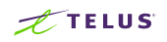
Great Northern Corporation is not only invested in the physical health of our team members, but also the mental health of all our team members. We have an Employee Assistance Program (EAP) through telus.com. You can call at 1-800-456-1324, or message 24/7 and they will help you through a variety of issues:
- Marital and family Conflicts - Legal and Financial Counseling
- Job Related Difficulties - Identity Theft Counseling
- Stress, Anxiety and Depression - Financial Planning
- Parent and Child Relationship Issues - Various Other Related Issues
Available to team members and their family members in their household.

Other Benefits
Effective the 1st of the month following 30 days of employment.
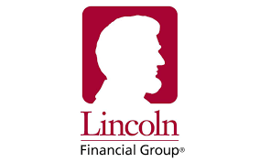
Life Insurance & Accidental Death and Dismemberment
Life insurance and AD&D Benefits are provided at no cost by Great Northern. The current benefit amount is $34,000.
You can purchase additional life insurance for yourself, spouse, and dependent children.

Voluntary Critical Illness Coverage
Critical illnesses can be a major detriment to your income. UnitedHealthcare’s Critical Illness Protection Plan is designed to help ensure that, should you be diagnosed with a covered critical illness, you’ll have the financial support to help you continue to pay your daily living expenses. UnitedHealthcare sends a lump-sum payment directly to you after your diagnosis to help you stay on top of your bills. Cost depends upon age.

Jury Duty
Pay Difference

Voluntary Accident Protection Plan
We never know when an accident will occur and the impact it can have on our wallet can be tremendous. UnitedHealthcare’s Accident Protection Plan will pay money back to you if you have a covered injury and need care. The amount you receive is based on the covered expenses resulting from the accident. After a submitted claim is verified, the plan will send the benefit payment directly to you. You can use the money any way you see fit, including paying your health plan deductible and other out-of-pocket costs, paying your mortgage, rent, and more.

Sickness and Accident Benefits
Up to 26 weeks @ $400.00 per week, 100% company paid.
Begins 1st day for an injury and 4th day for an illness.

Long Term Disability
60% of Salary – Maximum of $6,000 monthly until age 65. 100% company paid.

Funeral Leave
Funeral leave is available on the first of the month following 30 days.
Regular full time team members will be allowed funeral leave up to five (5) days with pay to attend the funeral of a spouse, child, and parent.
Regular full time team members will be allowed funeral leave up to three (3) days with pay to attend the funeral of a brother, sister, father-in-law, mother-in-law, grandchildren, and grandparents.
Team members may take only one (1) day funeral leave (day of funeral), for a team member's great grandparents, brother-in-law, sister-in-law.

Health Fitness Reimbursement
Annual Reimbursement of up to $175 that can be used on a gym membership, home exercise equipment, participation in classes and/or programs such as aerobics and weight watchers, and smoking cessation.

